# Moogle Awareness Site Plan

## Isaac Nash

## WDD 130

## Overview

### Purpose

The purpose of this website is to educate visitors about Moogles—their history, culture, and importance—while promoting appreciation, awareness, and engagement. The site aims to present Moogles as more than side characters by highlighting their contributions, roles, and charm. It invites users to learn, explore, and support Moogle-focused initiatives.

### Audience

This website is for fans of fantasy creatures, gamers, creative thinkers, and anyone curious about Moogles. It serves newcomers seeking friendly information, longtime enthusiasts wanting deeper lore, and community members interested in supporting Moogle-themed activities and awareness efforts.

## Branding

### Website Logo

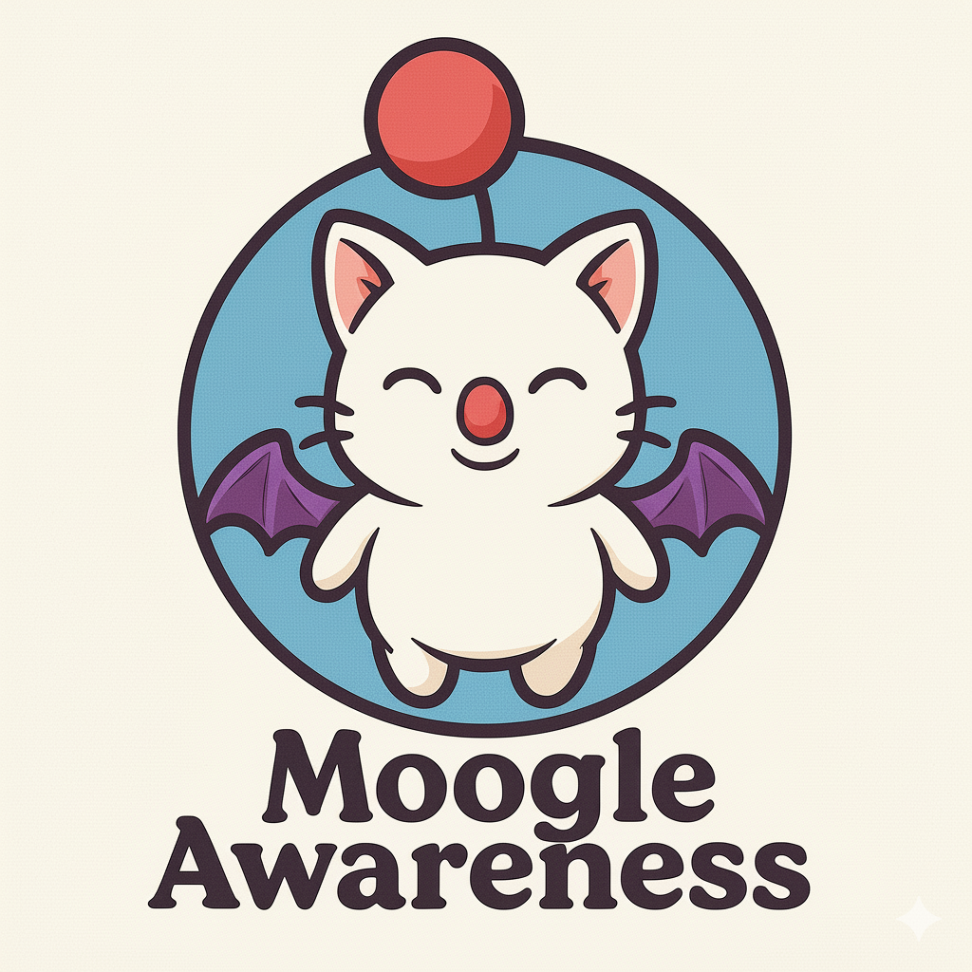

## Style Guide

### Color Palette

| **Primary** | **Secondary** | **Accent 1** | **Accent 2** |
| --- | --- | --- | --- |
| #F5E7D3 | #4A8F5A | #E64A4A | #7DB9D9 |

### Typography

#### Heading Font: Playfair Display

#### <https://fonts.google.com/specimen/Playfair+Display>

#### Paragraph Font: Nunito

#### <https://fonts.google.com/specimen/Nunito>

### Navigation

Home Page About Moogles Culture and Society

**Content**

**🏠 Homepage**

### Welcome to Moogle Awareness!

Moogles are small, winged creatures known for their bright pom-poms, cheerful attitudes, and incredible helpfulness. Loved across many realms, they serve as messengers, engineers, guides, and trusted companions. Their kindness, creativity, and bravery make them essential to the worlds they inhabit. This site is dedicated to celebrating who they are, sharing their stories, and spreading awareness of the joy they bring wherever they flutter—*kupo!*

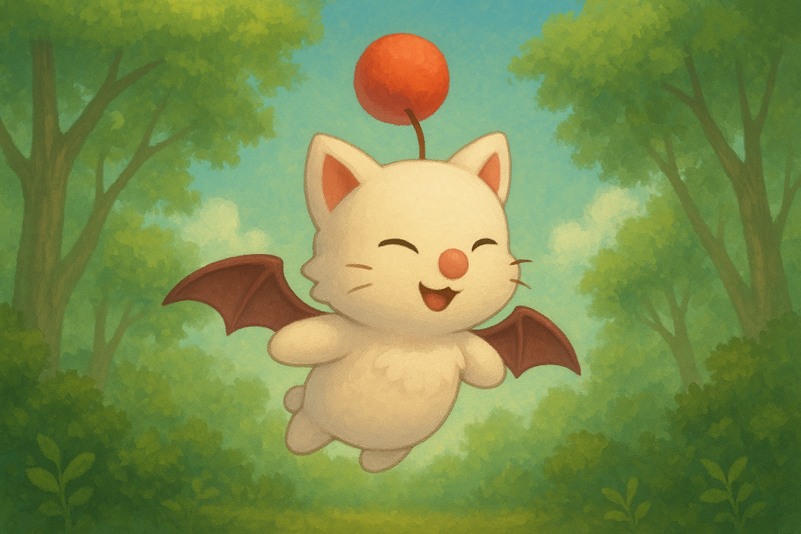

📖 **About Moogles Page**

## ✨ Physical Traits

Moogles are instantly recognizable by their fluffy white fur, small bat-like wings, and signature red or pink pom-pom that hovers above their heads. Though small in stature, they are agile and surprisingly strong. Their wings allow short-distance flight or gliding, and their expressive faces make their emotions easy to read. Moogles communicate verbally—often ending their sentences with “Kupo!”—and use body language to further express excitement, concern, or curiosity.

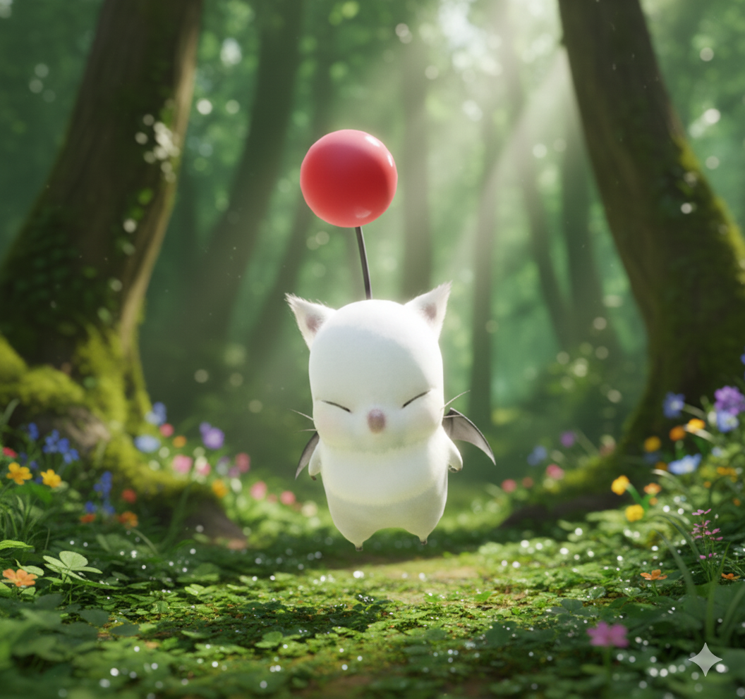

## 📜 Origin & History

Moogles have been part of magical worlds for centuries, known for their small size, bright pom-poms, and incredible resourcefulness. According to legend, they were originally forest-dwelling creatures who learned to glide through the trees using tiny wings. Over time, they became trusted companions to travelers, adventurers, and engineers. Across countless stories and realms, Moogles have served as messengers, mechanics, and guides—always eager to help with a cheerful *“Kupo!”*

## 💖 Personality & Abilities

Moogles are known for their warm, loyal personalities. They are friendly, clever, and incredibly hardworking. Many Moogles excel in technical tasks such as crafting, repairing machinery, or managing magical artifacts. Others serve as mail carriers, explorers, or caretakers. Despite their cuteness, they are brave and dependable, always stepping up when their friends or communities need them most. Their combination of optimism and skill makes them beloved throughout the realms.

🌍 **Moogle Culture & Society Page**

## 📦 Roles in Their World

Moogles play a wide variety of important roles across the realms. Many serve as **messengers**, delivering letters, items, and even magical artifacts with remarkable reliability. Others work as **engineers and inventors**, repairing airships, crafting tools, or maintaining complex machinery. Some Moogles take on roles as **healers, guides, librarians, explorers, or helpers**, supporting both adventurers and everyday community life. No matter the task, Moogles approach their work with enthusiasm, creativity, and a strong sense of duty.

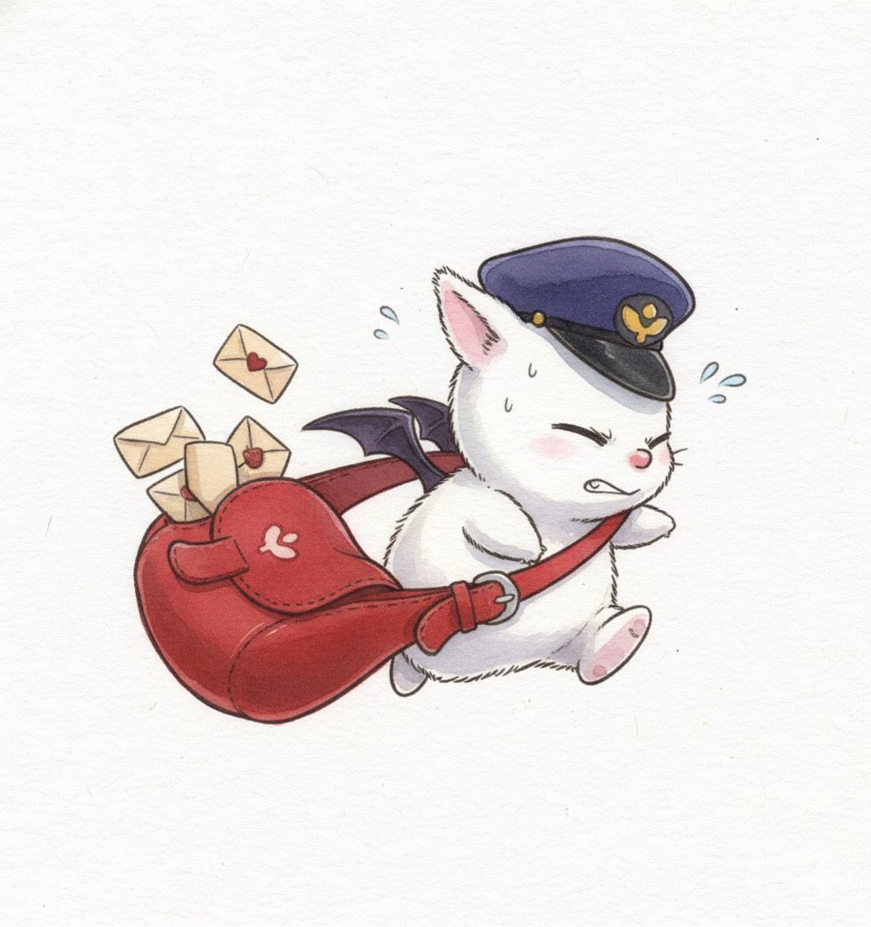

## 💬 Customs & Communication

Moogle culture thrives on community, kindness, and joyful expression. Their most iconic phrase, **“Kupo!”**, is used as a greeting, an exclamation, or a punctuation of excitement. Moogles also communicate through subtle wing flicks, pom-pom movements, and expressive gestures. They value cooperation and gather frequently in small villages or family groups where storytelling, crafting, and shared meals strengthen their bonds. Their customs reflect harmony and teamwork, making Moogle communities some of the most welcoming anywhere.

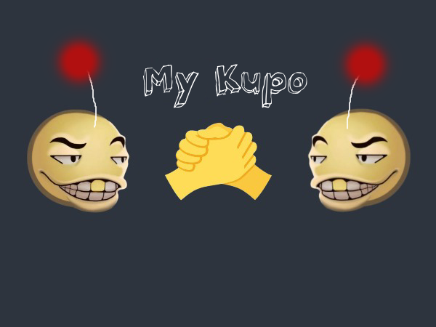

## ⭐ Notable Moogles in History

Throughout history, several Moogles have earned recognition for their bravery, intellect, or leadership. Some have served as trusted advisors to heroes, offering wisdom at critical moments. Others have been master craftsmen, building legendary machines or magical items. A few adventurous Moogles became famous explorers, mapping unknown lands and forging new paths for their kind. Among the most iconic is **Good King Moggle Mog XII**, celebrated for his charismatic leadership and for the legendary tale in which he lowered a rope from the heavens where they used to live, allowing Moogles to safely descend to the mortal realm—sacrificing his own chance to follow. These standout individuals show that even the smallest creatures can accomplish incredible feats and inspire generations of Moogles to dream boldly.

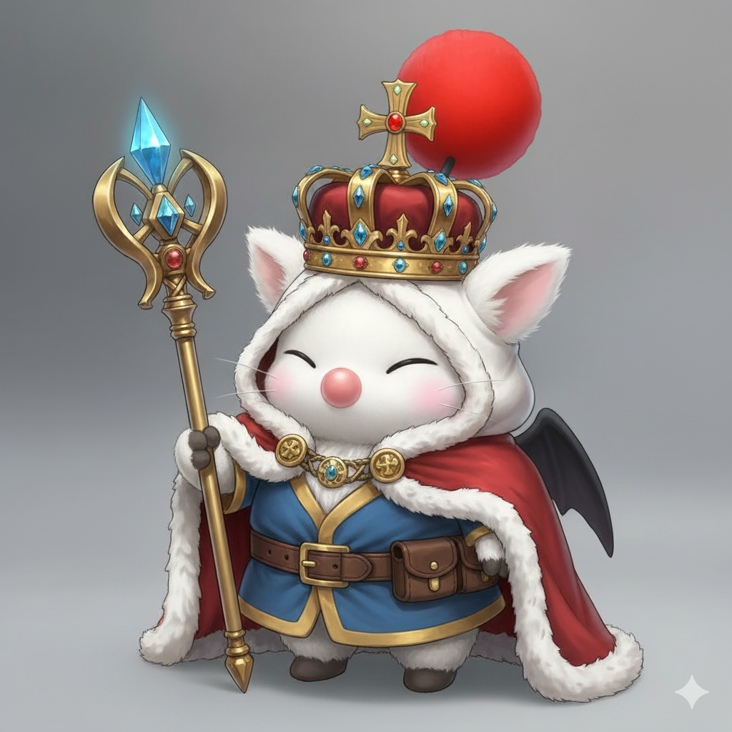

**Wireframes**

### Home

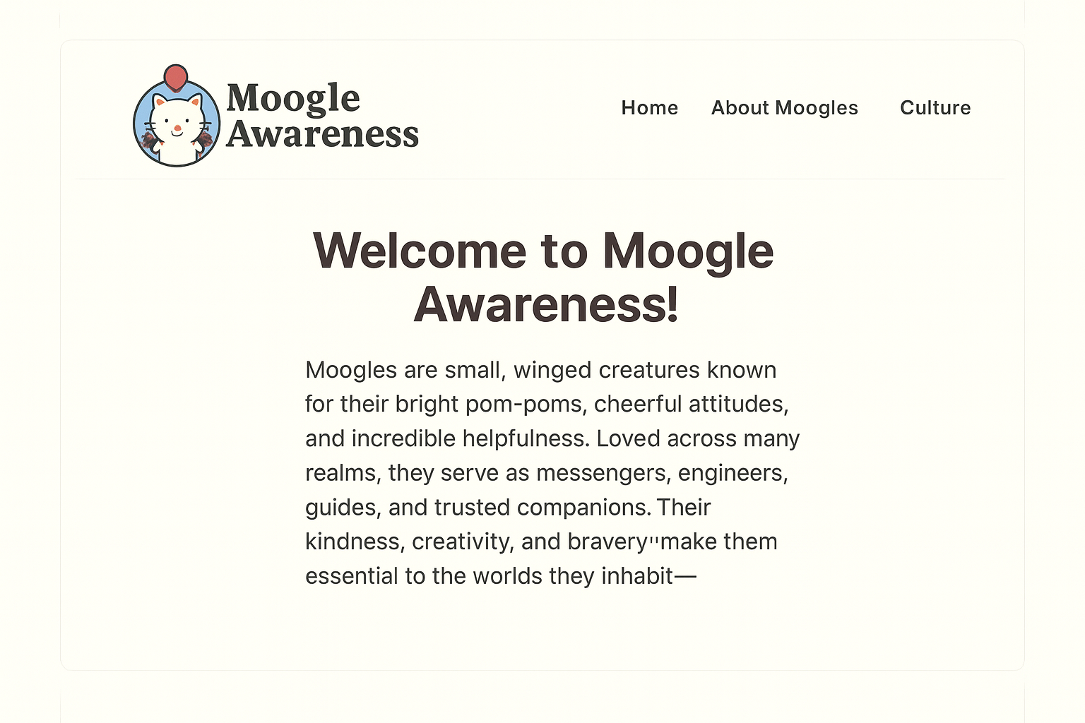

The pages should be about like this, with the images under each paragraph like in the site-plan above.